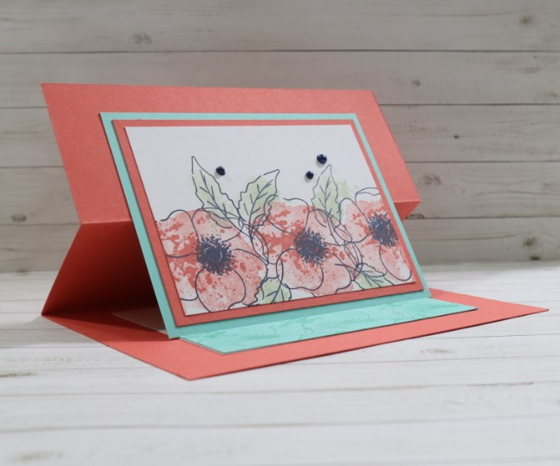

CUTTING DIMENSIONS
Card base: 5 ½” x 8 ½”
- Score at 2 ⅛” and 4 ¼” and fold the card base in half at the 4 ¼” mark.
- Fold top half of the cardstock back at the 2 ⅛” score line; see figure 1.

TIP: Crease the folds with a bone folder to help the card lay flat.

Cardstock:
- Top layer – 2 ¼” x 3 ¾” & 3” x 4” (Basic White – 159276)
- Middle layer – 3” x 4” (Calypso Coral – 122925)
- Bottom layer – 3 ¼” x 4 ¼” & 1” x 4” (Coastal Cabana – 131297)
- Inside of card –
  - white cardstock 3” x 4”
  - Coordinating cardstock with bottom layer 1” x 4” (Coastal Cabana)

STEPS
- Stamp your desired image on your white cardstock that will be the top layer.
- Adhere all three layers of cardstock as seen in top image.
- Adhere the top half of the layered stamped image to the top fold of the card base; see figure 2.
- Inside the card, adhere the 3” x 4” piece of Basic White cardstock and then adhere a 1” x 4” piece of Coastal Cabana to the bottom of the Basic White; see figure 2 below. This piece of Coastal Cabana will be used to help prop up the card; see figure 3.
- Stamp your favorite sentiment inside or leave it blank; see figure 2.
  - Using a stamping tool like a Misti® helps with stamping your sentiment straight and centered.
- Optional step is to add enamel dots or rhinestones to the front of the card; see figure 3.

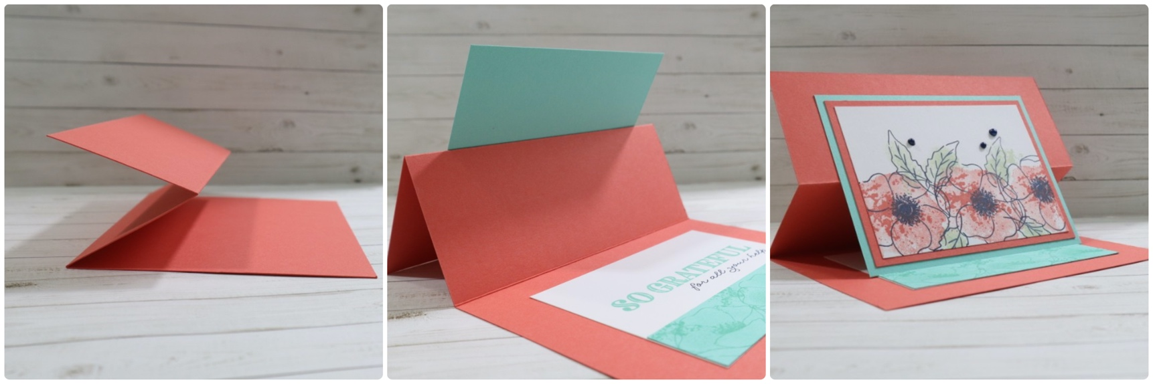
Figure 3
Figure 2
Figure 1

All stamped images in this document are ©2020 Stampin’ Up! unless otherwise stated. This printable PDF and the contents are my sole responsibility as an Independent Stampin’ Up! Demonstrator and is not endorsed by Stampin’ Up!

